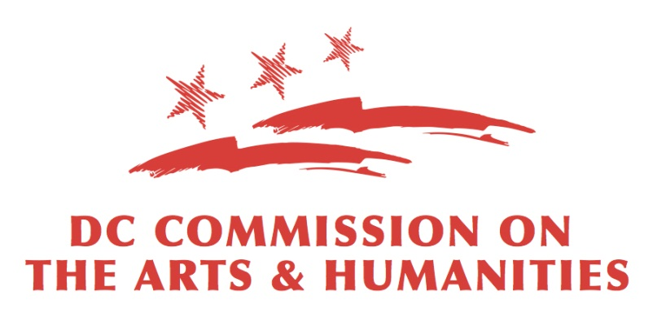

Mayor Marion S. Barry Summer Youth Employment Program (MBSYEP)

“Road Map” Form
This form is designed to support and complement the Work Samples and Support Materials of your application. It should also provide the necessary details of programmatic scope with the understanding that not all of the details may be available to the applicant at the time of submission.

Organization Name:

Point of Contact:

Address:

Telephone:

Email:

Youth Selection:
Circle/highlight ideal number and age range of youth contractor would like to accommodate (Check all that apply)

- Number of Youth
3-5 Youth ($2,500) | 6-10 Youth ($5,000) | 11-15 Youth ($7,500)
16-20 Youth ($10,000) | 21-25 Youth ($12,500) | 26-30 Youth ($15,000)

- Age of Youth
14-15 | 16-21 | 22-24

- Are you planning to select the youth working with your site or would you like them selected by CAH?
I/We will manage youth selection | I/We will need selection assistance from CAH

Contractor Scope of Work & Youth Goals:
Youth participants in SYEP are, for the most part, “early in their process” and understanding of the skills necessary for employment in the arts and humanities fields. DC Commission on the Arts and Humanities (CAH) encourages contractors to consider youth participants as paid interns, where staff members at those organizations mentor them in their skill development and knowledge of careers in the arts and humanities.

Provide a brief (one paragraph) description of the scope of the six-week experience the youth will have at your site. You are also asked to identify 3-5 overarching goals for the youth i.e. what they will learn and be able to do by the end of the program. You are encouraged to identify specific outcomes for each week/section of your program and specific outputs for the entire program.

Scope of Work

Goals for Youth Participants

Goal #1

Goal #2

Goal #3

Cleared Criminal Background Check

______ The Department of Employment Services requires any site supervisors who work with participants under the age of 18 years old to have cleared criminal background checks. Criminal background checks are conducted prior to the SYEP start date and costs are covered by the Department of Employment Services. Host sites may provide proof of recent (within two years) cleared criminal background checks, or they must attend an appointment scheduled by Department on Employment Services. Please initial to indicate you have read and understand the policy on background checks.
Youth Field Trips

______ Youth field trips take place on July 13, 18, and 27, and are a key component to youths’ understanding of the scope of careers available to them in the arts and humanities. It is mandatory that youth attend at least one field trip (new to FY2018). Contractors should plan schedules so that youth may attend the field trip within their weekly paid hours. Please initial to indicate you have read and understand the new policy regarding field trips.

*Optional: Indicate your first, second, and third date preference to participate in the field trip:

__ Friday, July 13, 2018
__ Wednesday, July 18, 2018
__ Friday, July 27, 2018

Final Showcase

A final sharing of the work of SYEP will take place on Friday, August 3rd. Do you anticipate being able to have your youth attend and participate in this event?

Yes No

Week 1
(June 25-June 29)

Objectives & Outcomes:
(List the specific objectives and outcomes of the week i.e. what youth should know and be able do to by the end of the week)

Procedures/Activities:
(List the process of activities in which the youth will engage)
Skills:
(List both soft and concrete skills that youth participants will gain from your program.

Soft professional skills include, but are not limited to teamwork, problem solving, conflict resolution, and leadership.

Concrete professional skills include, but are not limited to learning an artistic technique or managing a box office.)

Week 2
(July 2-July 6)

Objectives & Outcomes:
(List the specific objectives and outcomes of the week i.e. what youth should know and be able do to by the end of the week)

Procedures/Activities:
(List the process of activities in which the youth will engage)
Skills:
(List both soft and concrete skills that youth participants will gain from your program.

Soft professional skills include, but are not limited to teamwork, problem solving, conflict resolution, and leadership.

Concrete professional skills include, but are not limited to learning an artistic technique or managing a box office.)

Week 3
(July 9-July13)
Objectives & Outcomes:
(List the specific objectives and outcomes of the week i.e. what youth should know and be able do to by the end of the week)

Procedures/Activities:
(List the process of activities in which the youth will engage)
Skills:
(List both soft and concrete skills that youth participants will gain from your program.

Soft professional skills include, but are not limited to teamwork, problem solving, conflict resolution, and leadership.

Concrete professional skills include, but are not limited to learning an artistic technique or managing a box office.)

Week 4
(July 16-July 20)
Objectives & Outcomes:
(List the specific objectives and outcomes of the week i.e. what youth should know and be able do to by the end of the week)

Procedures/Activities:
(List the process of activities in which the youth will engage)
Skills:
(List both soft and concrete skills that youth participants will gain from your program.

Soft professional skills include, but are not limited to teamwork, problem solving, conflict resolution, and leadership.

Concrete professional skills include, but are not limited to learning an artistic technique or managing a box office.)

Week 5
(July 23-July 27)
Objectives & Outcomes:
(List the specific objectives and outcomes of the week i.e. what youth should know and be able do to by the end of the week)

Procedures/Activities:
(List the process of activities in which the youth will engage)
Skills:
(List both soft and concrete skills that youth participants will gain from your program.

Soft professional skills include, but are not limited to teamwork, problem solving, conflict resolution, and leadership.

Concrete professional skills include, but are not limited to learning an artistic technique or managing a box office.)

Week 6
(July 30-August 3)
Objectives & Outcomes:
(List the specific objectives and outcomes of the week i.e. what youth should know and be able do to by the end of the week)

Procedures/Activities:
(List the process of activities in which the youth will engage)
Skills:
(List both soft and concrete skills that youth participants will gain from your program.

Soft professional skills include, but are not limited to teamwork, problem solving, conflict resolution, and leadership.

Concrete professional skills include, but are not limited to learning an artistic technique or managing a box office.)

