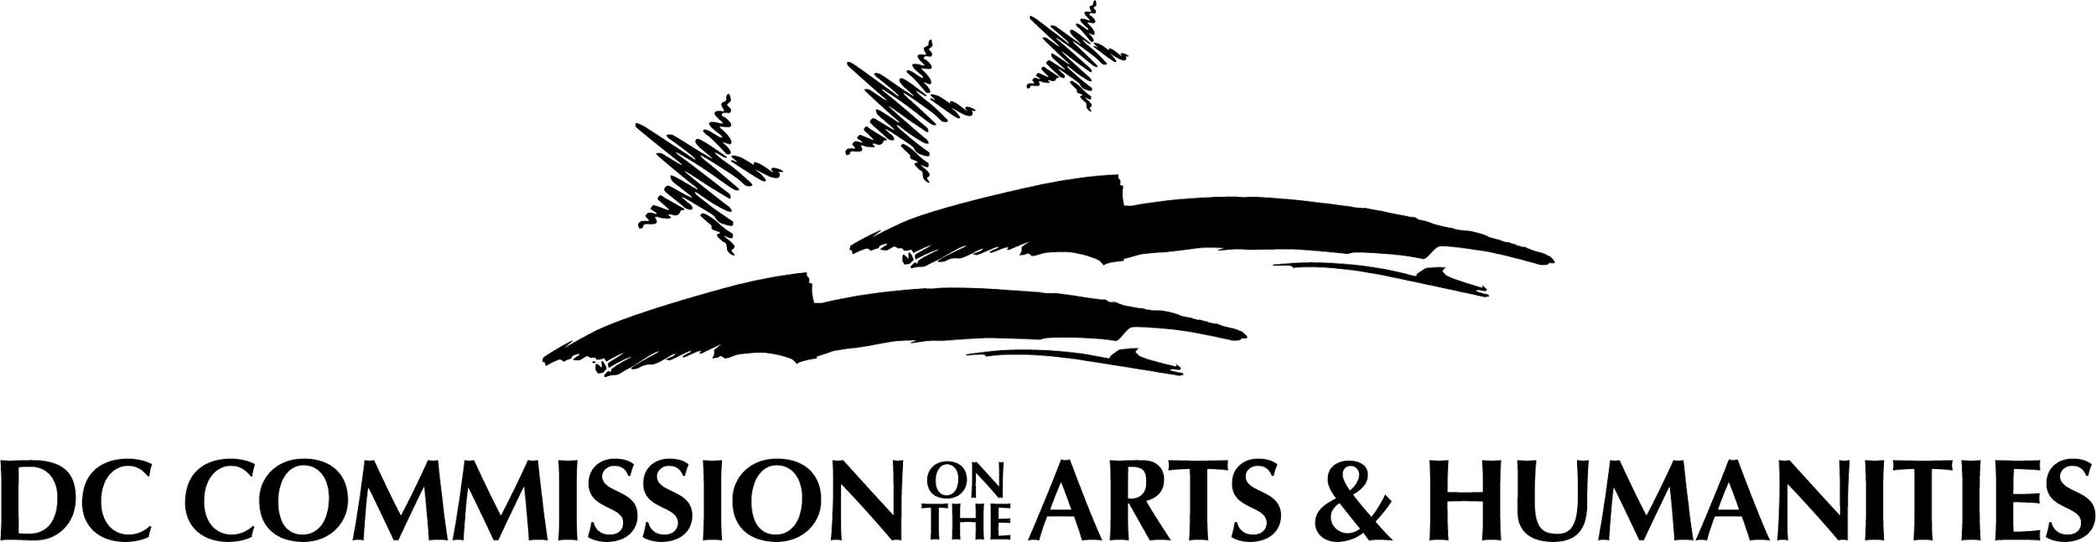

FY 2022
General Operating Support: Generalists
(Organization) Grant

Applicants may submit one (1) grant application to this program per fiscal year cycle

RFA Release: Wednesday | January 27, 2021 | 4:00 pm

Submission Deadline: Friday | February 26, 2021 | 11:59 pm

Application Questions

Overview

Group Name/Organization
(Up to 10 words)
(Required question)

Type of support:
(Indicate one of the three categories of General Operating Support)

GOS - Generalists

GOS – National Capital Arts Cohort (NCAC)

GOS – Service Organizations

Have you applied for a grant from CAH in the past 5 years?

Has the organization’s address changed in the past 12 months? If the address has changed, the following entities must be notified: (a) Grant Manager at CAH; (b) Procurement Center of Excellence; and (c) DC Vendor Portal.
(Yes or No)

Request

Organization Profile

In which ward is the applicant located?
(Required question)

Applicant Primary Discipline:
(Required question)

Applicant Secondary Discipline (if applicable):

Organization founding date: Responses must be formatted as follows: mm/dd/yyyy.
(Required question)

Organization fiscal year (e.g. July 1 – June 30):
(Required question)

Institution type:
(Required question)

What is the organization’s mission and vision?
(Up to 200 words)
(Required question)

Please list the organization’s top three accomplishments from the past two years:
(Up to 200 words)
(Required question)

Request Details

Projects & Programs

List all DC-based programs, projects, or initiatives that will take place during the year covered by the grant period. Please group activities into categories and provide enough detail to show the breadth of organizational scope. Program costs should be inclusive of personnel. Total costs should match total in corresponding budget section of application. (At least 1 project description is required. Up to four additional programs may be added)

Example:
Program type: Arts Education
Program cost: $15,000
# of audience/youth served: 5000
Brief description (200 words)

District Impact & Engagement

Describe how the organization has identified a need for its programming/services in DC and how it engages DC audiences in the same.
(Up to 400 words)
(Required question)

Specify strategies used to determine organizational impact through evaluation. Describe changes implemented as a result of internal and/or external evaluation processes.
(Up to 400 words)
(Required question)

I.D.E.A.

Provide examples of how the organization works with intentionality in the planning and implementation of its programming and services to promote inclusion, diversity, equity, and access for audiences, participants, staff, and board. Please upload any documents to support this work e.g. a strategic plan.
(Up to 600 words)
(Required question)

Budget Narrative, Capacity & Sustainability

Total FY 2020 organizational cash expenses as listed on Line 18 of the organization’s 990 (do not include in-kind expenses).
(Required question)

Total FY 2020 organizational cash expenses for DC-based arts and humanities programming, if different from above. Total must match total in Projects & Programs section of application.
(Required question)

Provide a budget narrative. Describe how the amounts allocated to the budget line items advance organizational mission. Please provide relevant details and any additional clarifying information. Include the sources of any required matching funds and whether the funding is secured or pending.
(Up to 400 words)
(Required question)

How many full-time employees are DC residents?
(Required question)

How many full-time employees are non-DC residents?
(Required question)

How many part-time employees are DC residents?
(Required question)

How many part-time employees are non-DC residents?
(Required question)

Work Samples & Uploads

Provide a statement describing how and why the arts, humanities and/or arts education content or scope of services in the materials uploaded best represent the applicant.
(Up to 400 words)
(Required question)

Balance Sheet (from most recently completed fiscal year):
(Required upload)

Certificate of Clean Hands (dated no more than 30 days prior to the deadline);
(Required upload)

Certificate of Liability Insurance (general liability)
(Required upload)

Current Organizational Budget (approved by the organization’s Board of Directors);
(Required upload)

Federal and DC Funding Form (required of organizations applying to GOS: NCAC);

IRS 501(c)(3) Letter of Determination;
(Required upload)

IRS Form 990 (most-recently submitted);
(Required upload)

IRS Form W-9
Note: Post office boxes are prohibited. The organization’s address MUST match the address in the grants portal, the address on file in the DC Government’s PASS system, and address registered in the DC Vendor Portal. Only the October 2018 version of the W9 form may be used and the form must be dated at the time of application submission;
(Required upload)

List of Current Board of Directors
Provide board roles (e.g. president, treasurer, etc.), responsibilities and home addresses/wards;
(Required upload)

Organizational Demographics Overview Form;
(Required upload)

Profit and Loss Statement (from most recently completed fiscal quarter);
(Required upload)

Résumés of Key Personnel
Examples include: artistic/managing/executive directors; arts educators; etc. Provide roles, areas of responsibility, and home addresses;
(Required upload)

Statement of Certification (signed at the time of application);
(Required upload)

Support Materials
Up to three (3) internally-produced items (e.g. curricula, strategic plans, marketing materials, etc.) and up to three (3) externally-produced items (e.g. reviews, commendations, testimonials, letters of support, etc.); and
(Required upload)

Work Samples
CAH recommends reviewing the Work Sample Addendum to determine materials that might best support the application.
(Required upload)

The Arrest and Conviction Statement and Data Arts Report are no longer required for CAH applications.

Templates and instructions available at: http://dcarts.dc.gov/page/managing-grant-awards).

