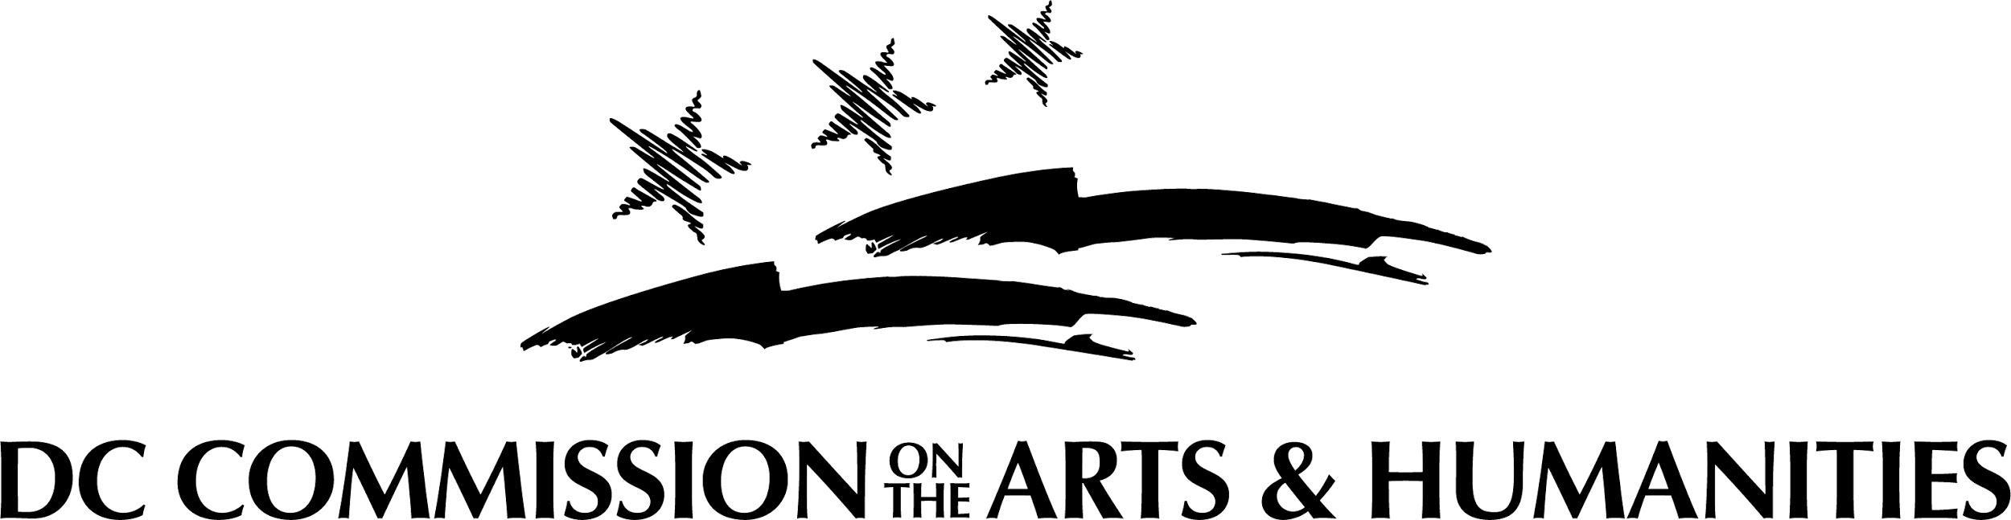

FY 2022 MURALSDC

GRAFFITI AND AEROSOL MURAL ARTISTS

Applicants may submit one (1) MuralsDC application per grant cycle

The DC Commission on the Arts and Humanities (CAH), in partnership with the DC Department of Public Works (DPW), seeks graffiti and aerosol mural artists and artist teams to design, create and install aerosol murals as part of the MuralsDC program.

The MuralsDC program was established to beautify neighborhoods and communities in the District of Columbia with artistic works. This initiative also aims to; 1- Positively demonstrate the culture and techniques of graffiti art to District youth and others, 2-Promote respect for public and private property, and 3-Heighten community awareness. There are over 150 MuralsDC projects across all eight wards of the District of Columbia.

FY2022, MuralsDC is the 15th Anniversary of the MuralsDC initiative. To celebrate this milestone CAH and DPW are seeking bold and new, next-level designs from artists across mediums that use traditional aerosol graffiti in their practice. Muralists must demonstrate experience executing large-scale exterior murals. Designs with content that promotes Love, Peace, Hope, Harmony, Unity, Thought, Change, and Beauty are encouraged. This application is open to local, national and international artists.

FY 2022 MURALSDC
RFQ Release: Friday | April 15, 2022, 4pm ET
Submission Deadline: Thursday | May 26, 2022,11:59pm ET

MURALSDC Application Questions
Please use this document to preview the application questions in the grant portal. It is recommended that you type your answers out in a separate word document then copy and paste your response into the portal. For assistance contact Deirdre Darden Deirdre.darden@dc.gov

OVERVIEW
Artist and/or Team Name:
(Required – Name of applicant/lead artist as it appears on the applicant’s official tax documents)

Amount Requested:
($XXXX) $10,000 - $25,000

Type of Support:
(Select “Project Support”)

Project Begin Date:
(10/1/2021 – this is the start of FY22)

Project End Date:
(9/30/2022 – this is the end of FY22)

Briefly detail the arts and humanities activities and goals during the grant period
(Not required – enter “N/A”)

Have you applied for a grant from CAH within the past 5 years?
(Required)

Have you received a grant from CAH within the past 5 years?
(Required)

Has your address changed in the past 12 months?
(Required – If address has changed, it must be updated in the grants portal)

REQUEST
Request Details

Personnel. If working solo, type N/A. If working with another artist or collaborator, please list the individual's full legal name, residency, and describe their role with the project. Also, please upload their resume or bio in the “Bios of Artist Team Members” upload section.
(Required – 200 words max.)

Artist Statement. Describe your (or artist team’s) 1) experience with large-scale exterior mural work and 2) approach to the theme. Consider the Application Review and Selection Criteria factors in your response. (Required – 500 words max.)

Budget. Provide budget details that reflect the cost for development, fabrication, installation of all elements of the project. Budget should consider allowable Costs. Provide brief Narrative and upload spreadsheet of projected costs in the “Budget” upload section. (Required – Narrative 200 words max: plus, spreadsheet)

Activities Details/Timeline: Provide a projected timeline to develop, fabricate and install the requested art objects within the stated timeframe. (Required – 300 words max.)

Applicant Profile/Details

Applicant First Name:
(Required)

Applicant Middle Name:

Applicant Last Name:
(Required)

Applicant Suffix:

Applicant Street Address 1:
(Required)

Applicant Street Address 2:

Applicant City:
(Required)

Applicant State:
(Required)

Applicant Zip:
(Required)

Country:

DC Ward:

Applicant SSN:
(Required)

Applicant Login Email Address:
(Required)

Applicant Secondary Email Address:

Applicant Phone:
(Required)

Applicant Secondary Phone:

Applicant Website:

Applicant Discipline:
(Required – Select 05 Visual Arts)

WORK SAMPLES & UPLOADS

Work Sample Narrative: Provide a statement describing how the content of the work sample(s) best represent(s) the applicant and/or the work supported by the request.
(Required – 150 words max)

Image Identification List that includes Artist Name, Title, Date, Medium, Location, and Project Budget for each image.
(Required)

Artist Résumé/CV:
(Required)

Professional References: List of at least three (3). Please include name, address, phone number, and email address for each reference. You can also upload written professional referrals relevant for this project. (Required)

Support Material – See Addendum A in RFQ for more information.
(Optional)

Bios of Artist Team Members: (Required if applying as the Lead Artist for an Artist Team)

Signed IRS Form W-9:
(Required – Post office boxes are prohibited. The applicant’s address MUST match the address in the grants portal, the address on file in the DC Government’s PASS system, and the address registered in the DC Vendor Portal. Only the October 2018 version of the W9 form may be used and the form must be dated at the time of application submission: http://dcarts.dc.gov/page/managing-grant-awards)

Certificate of Clean Hands: (Required – For instructions on how to generate a certificate of clean hands, please visit: My Tax DC. Clean hands certificate is required to be dated within 30 days of application submission)

List of Insurance Carries and Policies:
(Required – General liability or project-specific insurance, template found at: http://dcarts.dc.gov/page/managing-grant-awards)

Statement of Certification:
(Required – Template found at: http://dcarts.dc.gov/page/managing-grant-awards)

Individual Demographic Overview Form: for artist and each artist team member. Completion and submission of this form will have no impact on funding decisions. Responses are used for statistical and diversity inclusion purposes only and will not be seen by the grant review panel. (Required – form found on grant application landing page)

