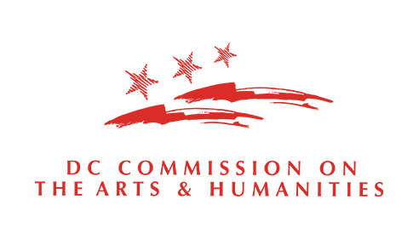

PUBLIC ART GRANT PROGRAM
Applicants may submit one (1) Color the Curb application per grant cycle

FY 2021
Color the Curb Program

RFA Release: Monday | June 28, 2021 | 4:00 pm ET
Submission Deadline: Friday | July 23 | 11:59 pm ET (Technical assistance available until 4:30 pm ET.)
Selected individuals receive $7500

Color the Curb Program Grant Application Questions
Please use this document to preview the application questions in the grant portal. It is recommended that you type your answers out in a separate word document before applying in the portal. For assistance contact Lauren Wilson, lauren.wilson@dc.gov.

OVERVIEW

Artist and/or Team Name:
(Required – Name of applicant/lead artist as it appears on the applicant’s official tax documents)

Amount Requested:
($7500)

Type of Support:
(Select “Project Support”)

Project Begin Date:
(10/1/2020 – this is the start of FY21)

Project End Date:
(9/30/2021 – this is the end of FY21)

Briefly detail the arts and humanities activities and goals during the grant period:
(Not required – enter “N/A”)

Have you applied for a grant from CAH within the past 5 years?
(Required)

Have you received a grant from CAH within the past 5 years?
(Required)

Has your address changed in the past 12 months?
(Required – If address has changed, it must be updated in the grants portal)
REQUEST

Request Details

Personnel: If working solo, type N/A. If working with another artist or collaborator, please list the individual's full legal name, residency, and describe their role with project. Also, please upload their resume or bio in the “Bios of Artist Team Members” upload section.
(Required – 100 words max.)

Artist Statement that describes uploaded artwork design(s) inspiration and connection to the District’s history, culture, and/or spirit; and your experience with or interest in working with communities:
(Required – 350 words max.)

Describe a time when you had to change course for a project. What were the circumstances and what was the outcome?
(Required – 150 words max.)

Is there a particular intersection you'd like to work with? Remember, CAH and DDOT will make the final pairings. (Optional – 20 words max.)

Applicant Profile/Details

Applicant First Name:
(Required)

Applicant Middle Name:

Applicant Last Name:
(Required)

Applicant Suffix:

Applicant Street Address 1:
(Required)

Applicant Street Address 2:

Applicant City:
(Required)

Applicant State:
(Required)

Applicant Zip:
(Required)

DC Ward, if applicable:

Applicant SSN:
(Required)

Applicant Login Email Address:
(Required)

Applicant Secondary Email Address:

Applicant Phone:
(Required)

Applicant Secondary Phone:

Applicant Website:

Applicant Discipline:
(Required – Select 05 Visual Arts)

WORK SAMPLES & UPLOADS

Provide a statement describing how the content of the work sample(s) best represent(s) the applicant and/or the work supported by the request.
(Required – Not actually required for this program, please put N/A)

Artist Résumé/CV:
(Required)

Artwork Design 1:
(Required - Uploaded as a PDF or JPG)

Artwork Design 2:
(Optional – Uploaded as a PDF or JPG)

Budget Template
(Required – use template provided)

Signed IRS Form W-9:
(Required - Post office boxes are prohibited. The applicant’s address MUST match the address in the grants portal, the address on file in the DC Government’s PASS system, and the address registered in the DC Vendor Portal. Only the October 2018 version of the W9 form may be used and the form must be dated at the time of application submission: http://dcarts.dc.gov/page/managing-grant-awards)

Certificate of Clean Hands:
(Required – For instructions on how to generate a certificate of clean hands, please visit: My Tax DC. Clean hands certificate is required to be dated within 30 days of application submission)

List of Insurance Carries and Policies:
(Required – General liability or project-specific insurance, template found at: http://dcarts.dc.gov/page/managing-grant-awards)

Artwork Relationship and Copyrights Form:
(Required – Template found at: http://dcarts.dc.gov/page/managing-grant-awards)

Statement of Certification:
(Required – Template found at: http://dcarts.dc.gov/page/managing-grant-awards)

Individual Demographic Overview Form:
(Required)
Bios of Artist Team Members: (Optional – Maximum of 1 additional artist)

