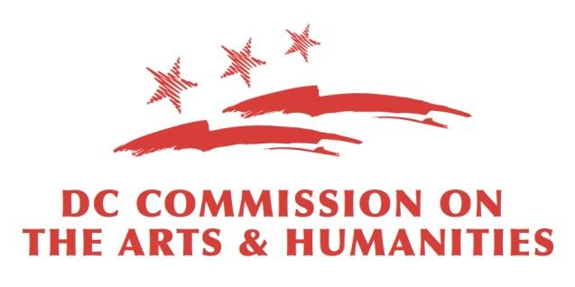

FY 2021
PROJECT-BASED CONTRACT

SPECIAL ARTS INITIATIVE:
CELEBRATE THE CREATIVE SPARK!
Applicants may submit one (1) Special Arts Initiative application per fiscal year cycle

Projects by Individuals
Individuals may request up to $1,000
Deadline: Friday, April 9, 2021 at 11:59PM EST

Award recipients must implement programming between
Tuesday, June 1, 2021 and Friday, August 6, 2021

Government of the District of Columbia
Commission on the Arts and Humanities
200 I (Eye) Street, SE, Suite 1400
Washington, DC 20003
Overview

Project Title:
(10 Words)
(Required)

Amount Requested:
(Required: $1,000)

Type of Support:
(Required: Project-based)

Project Start Date:
(Required: June 1, 2021)

Project End Date:
(Required: August 6, 2021)

Briefly detail the arts and humanities activities and goals during the contract period:
(200 Words)
(Required)

Have you applied for a grant from CAH within the past 5 years?
(Required)

Have you received a grant from CAH within the past 5 years?
(Required)

Has your address changed in the past 12 months?
(Required)

Request

Applicant Profile

Applicant First Name:
(Required)

Applicant Middle Name:
(Required)

Applicant Last Name:
(Required)

Applicant Suffix:

Applicant Street 1:
(Required)

Applicant Street 2:

Applicant City:
(Required)

Applicant State:
(Required)

Applicant Zipcode
(Required)

Applicant Login Email:
(Required)

Applicant Secondary Email:

Applicant Phone:
(Required)

Applicant Secondary Phone:

Applicant Fax:

Applicant Website:

Applicant LinkedIn:

In which ward is the applicant located?
(Required)

Applicant Discipline:
(Required)

Artistic Statement:
(Required)

Request Details

Workshop Attendance: Did you attend a workshop to help guide you in applying to this program?
(Yes/No)
(Required)

If applicable, provide past examples executing activities similar to this request. If not applicable, please describe why. Responses may include producing and/or presenting similar projects.
(300 Words)
(Required)

District Impact & Engagement

What modes of programmatic evaluation has the applicant used in the past? Provide examples of changes as a result of the evaluation(s). If none, explain why. What are the anticipated modes of evaluation the applicant will employ?
(300 Words)
(Required)

Work Samples & Uploads
Provide a statement describing how and why the arts, humanities, and/or arts education content or scope of services in the materials uploaded best represent the applicant.
(400 Words)
(Required)

Certificate of Clean Hands (visit www.mytax.dc.gov for instructions on how to generate a certificate of clean hands): Note: Form should be dated within 30 days of the deadline.
(Required)

Certificate of Insurance: (Required only if the applicant anticipates engaging in in-person residencies. All others should upload a single page statement declaring their intent to conduct programming virtually)

Resume of Lead Artist
(Required)

Statement of Certification (template here: http://dcarts.dc.gov/page/managing-grant-awards). Note: Form should be dated at time of submission.
(Required)

Support Materials: (Tip: Include sample curriculum, testimonies etc.)

W-9:
Post office boxes are prohibited. The applicant’s address MUST match the address in the grants portal, the address on file in the DC Government’s PASS system, and address registered in the DC Vendor Portal. Only the October 2018 version of the W9 form may be used and the form must be dated at the time of application submission.
(Required)

Work Sample: (Unit Plan)
The residency Unit Plan carries the most weight because it must contain the clearest depiction of what the applicant plans to do in the classroom as part of the project. Applicants should align their content activities to the three tenets of creativity as defined by Dr. E. Paul Torrance in the RFA (page 3).
(Required)

